**Assignment-1**

**Cloud Computing**

**Virtualization: Installing VirtualBox & Setting Up Multiple OSes**

**Objective: Install Oracle VirtualBox and create virtual machines (VMs) with different Linux distributions.**

**Step 1: Download VirtualBox**

Go to: https://www.virtualbox.org

Click **Downloads**

Choose **Windows hosts** to download the .exe installer

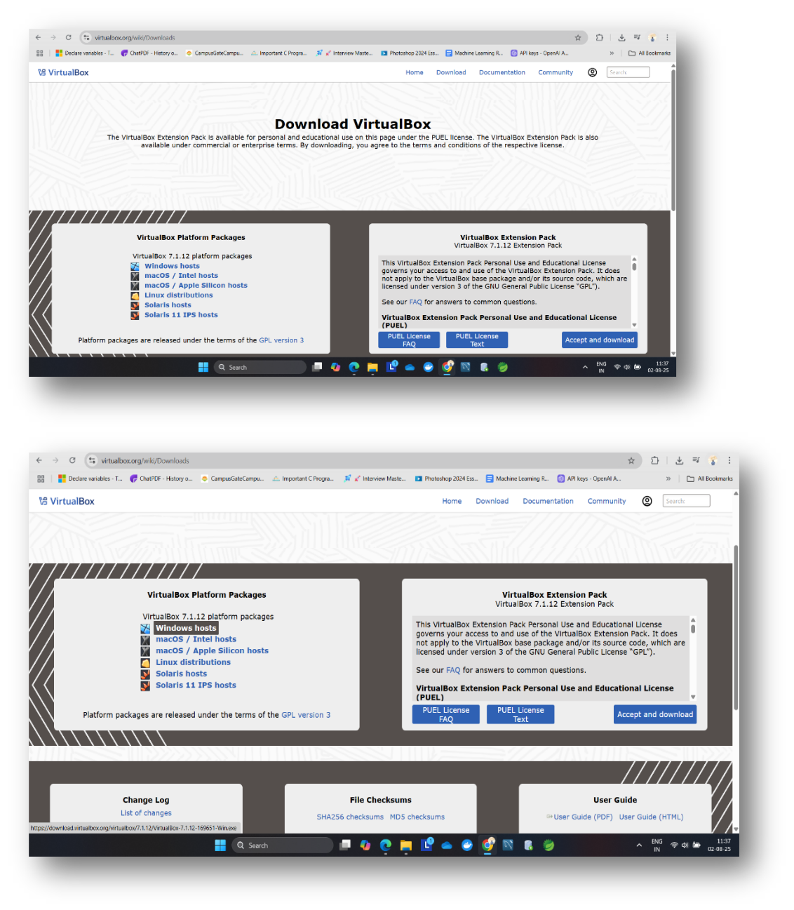

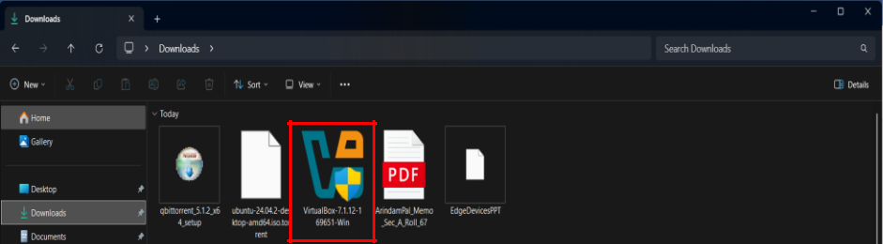

**Step 2: Run the Installer**

Double-click the downloaded .exe file

Click **Next** through the prompts (default options are fine)

Allow network access if prompted (important for VM networking)

Click **Install**, then **Finish** when done

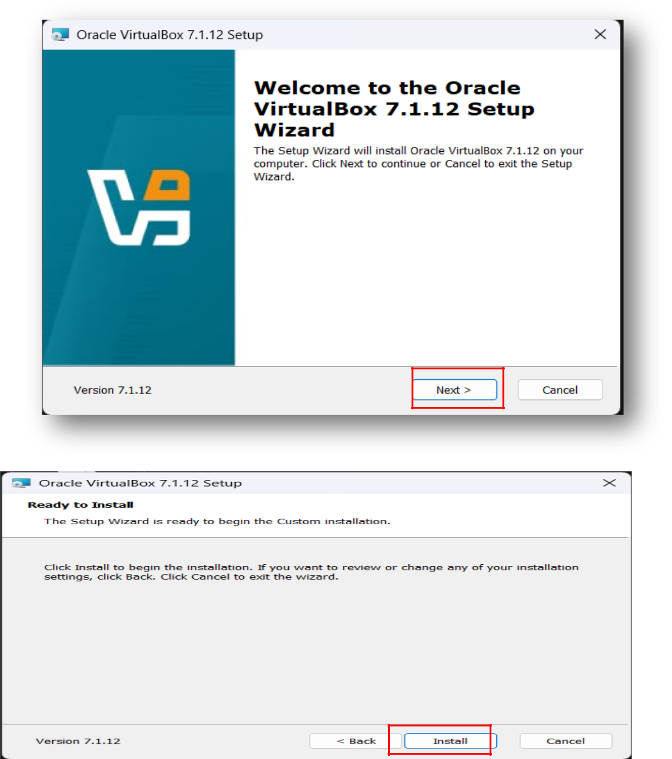

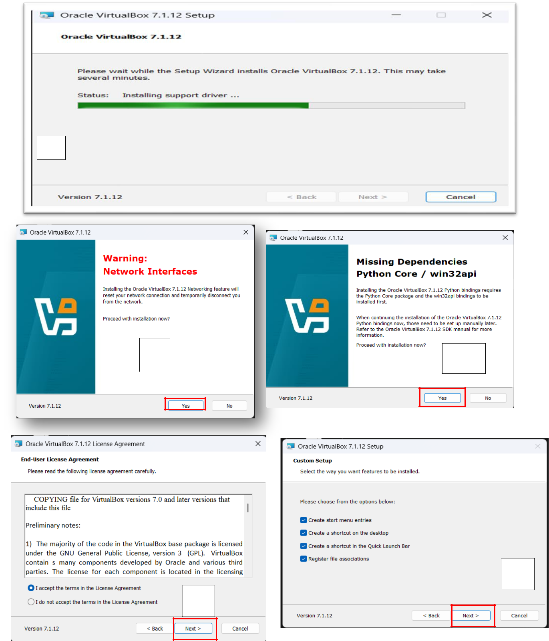

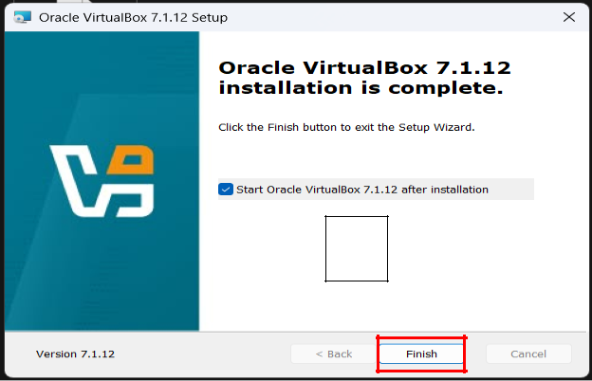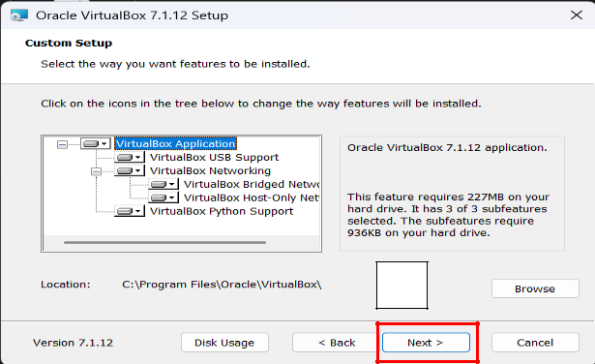

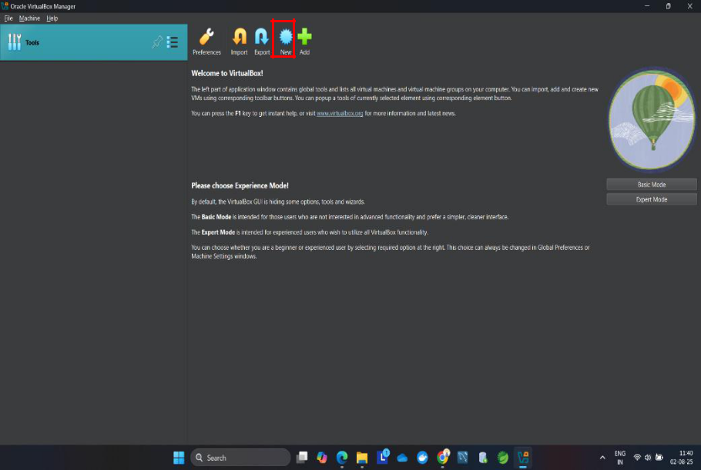**Create a New Virtual Machine**

**Step 1: Open VirtualBox and Create New VM**

* Click **"New"\**
* Name: Ubuntu
* Type: **Linux**
* Version: **Ubuntu (64-bit)**
* Click **Next**

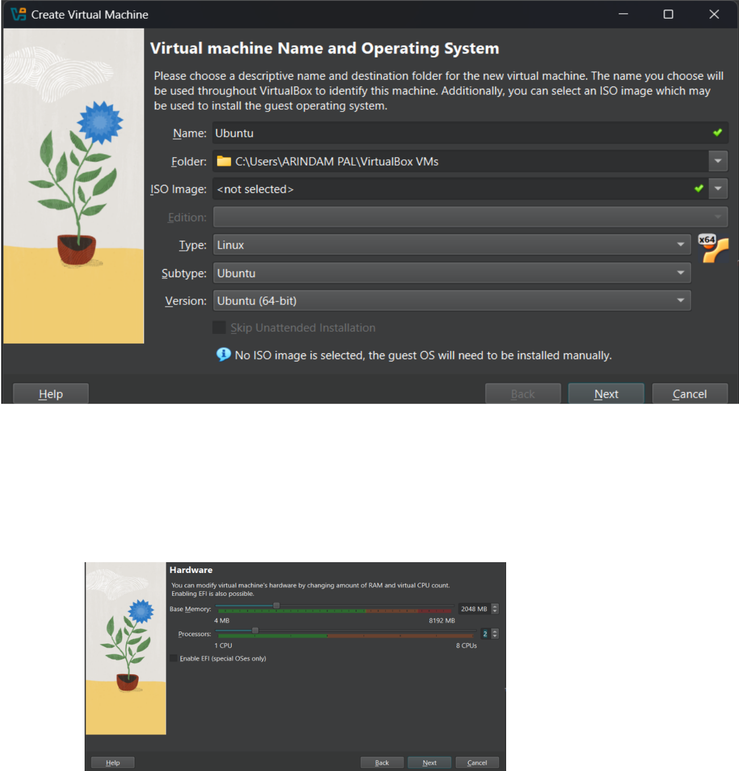

**Step 2: Set Memory Size (RAM)**

* Choose at least **2048 MB (2 GB)** for lightweight use
* **4096 MB (4 GB)** is better if your system has 8+ GB RAM

**Step 3: Create Virtual Hard Disk**

* Select: **Create a virtual hard disk now**
* Click **Create**
* Choose **VDI** (VirtualBox Disk Image) → Click **Next**
* Choose **Dynamically allocated** → Click **Next**
* Set disk size to **25–40 GB** → Click **Create**

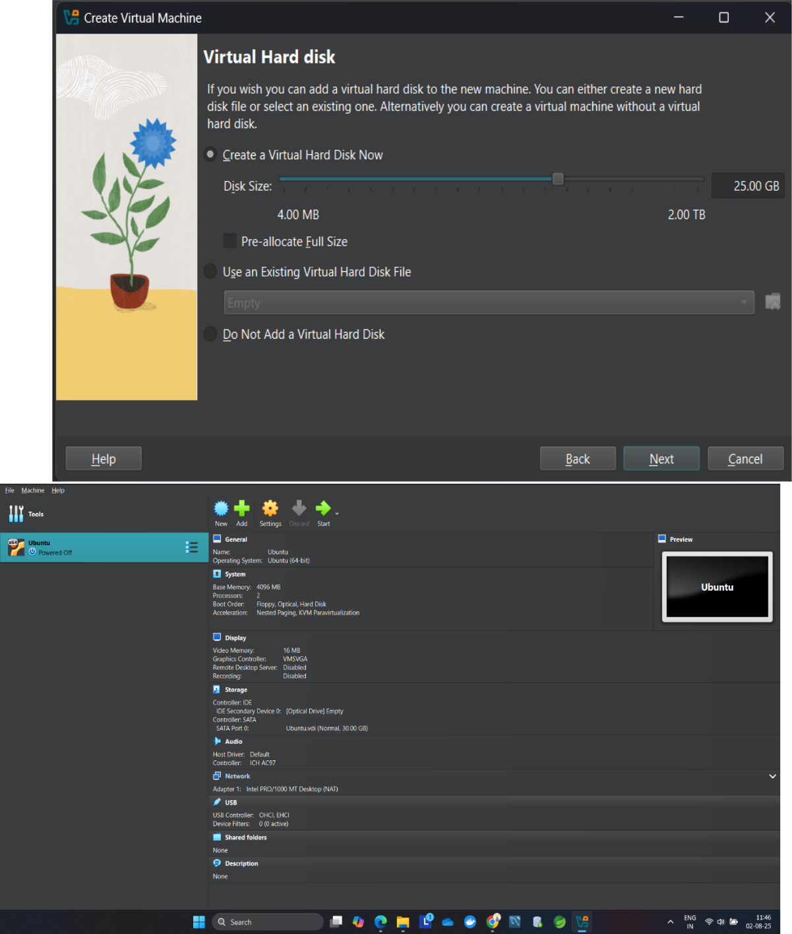

Download Ubuntu ISO

**Step 1: Get Ubuntu Desktop ISO**

* Go to: <https://ubuntu.com/download/desktop>
* Click **Download Ubuntu Desktop**

Wait for the **~5.9 GB** ISO file to download

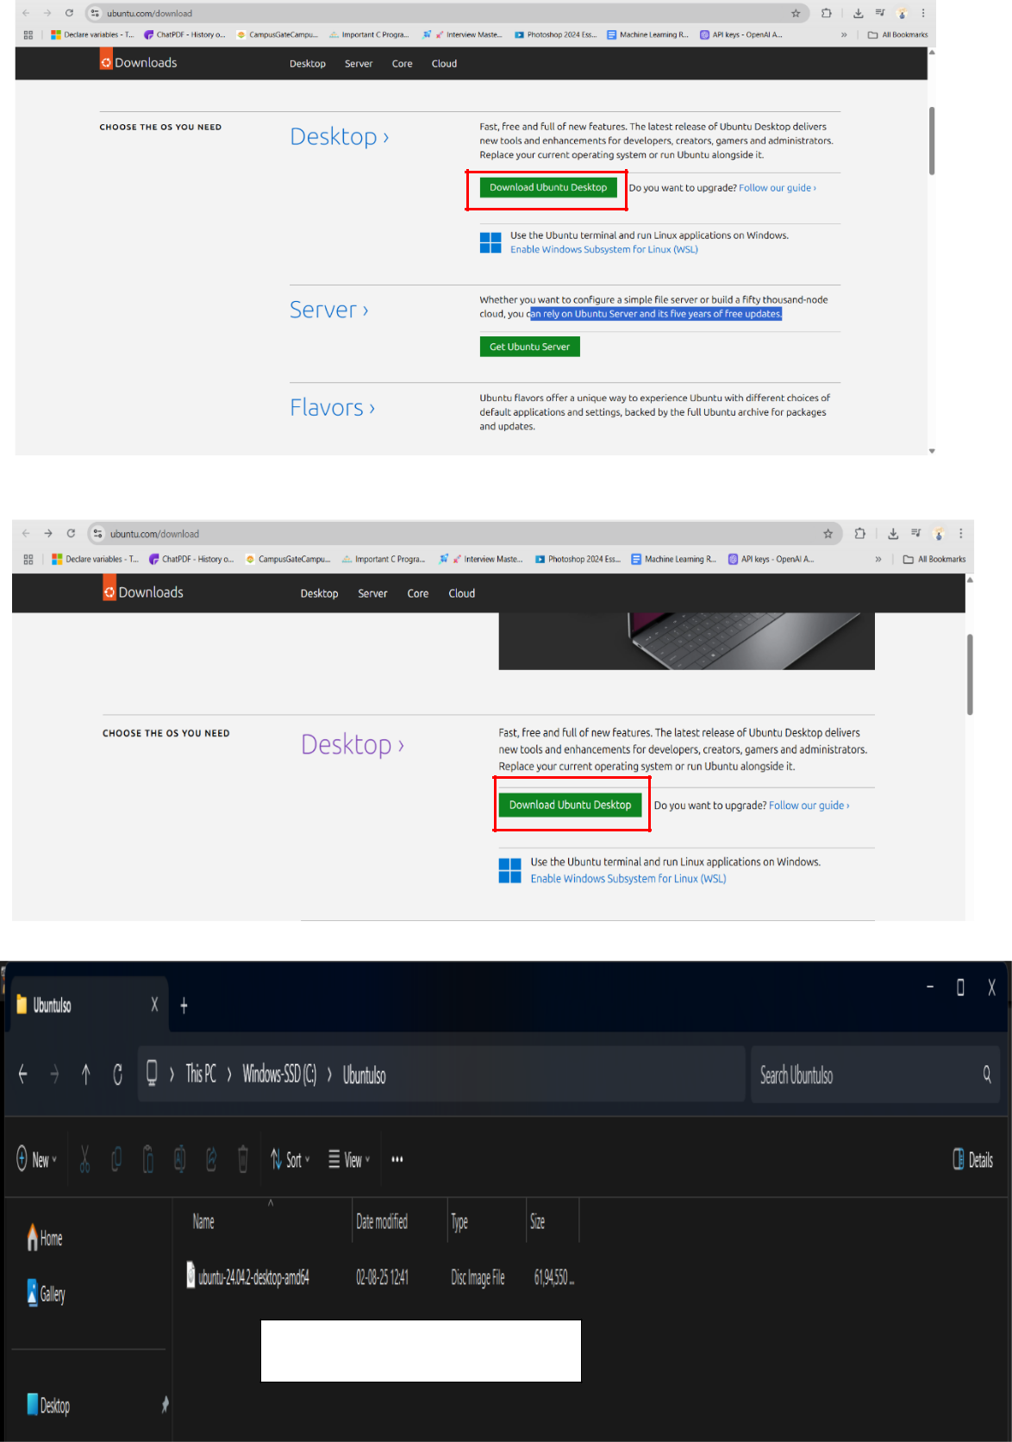

Downloaded File

Attach Ubuntu ISO

**Step 1: Go to VM Settings → Storage**

* Under **Controller: IDE**, click the empty CD icon
* On the right, click the CD icon again → Choose **"Choose a disk file…"**
* Browse and select the Ubuntu ISO you downloaded

**Step 2: Save and Start**

* Click **OK**
* Click **Start** on your VM

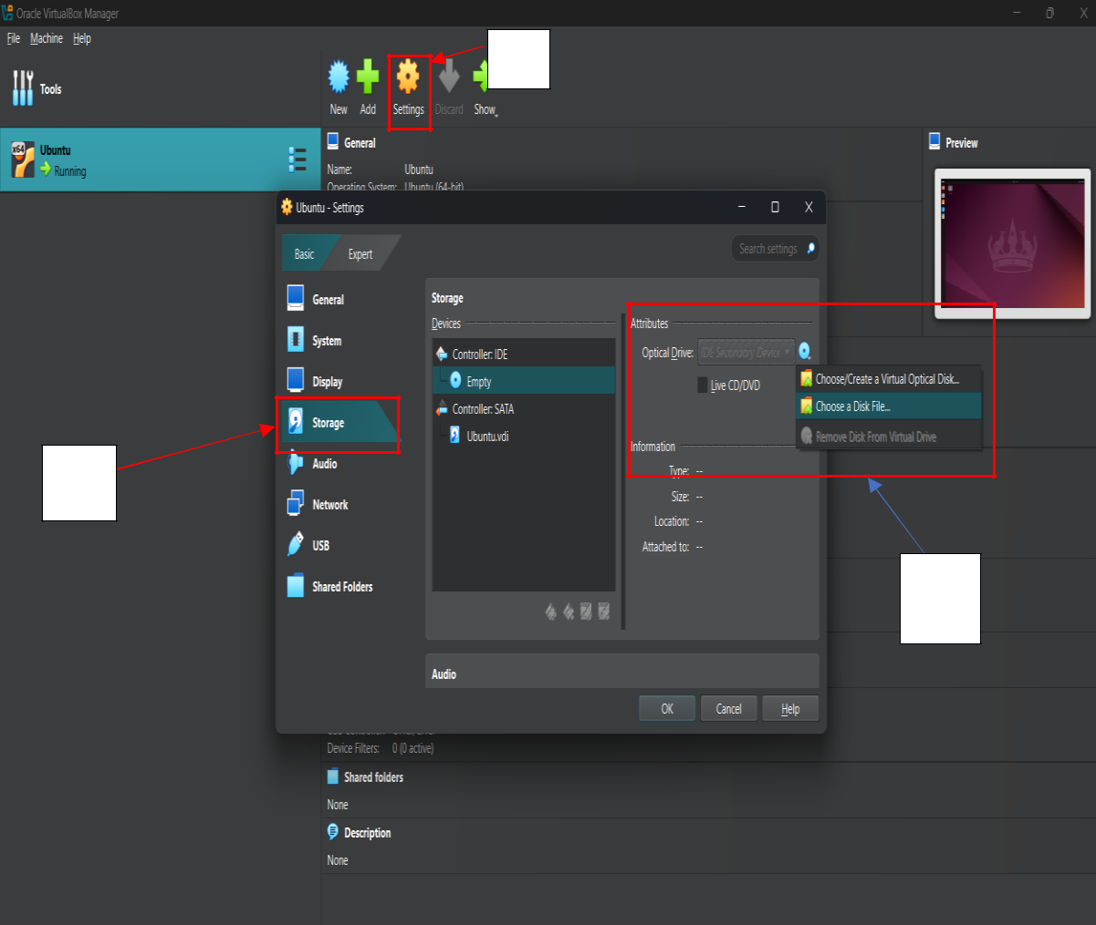

1

2

**Install Ubuntu OS in the VM**

**Step 1: Select "Try or Install Ubuntu"**

* 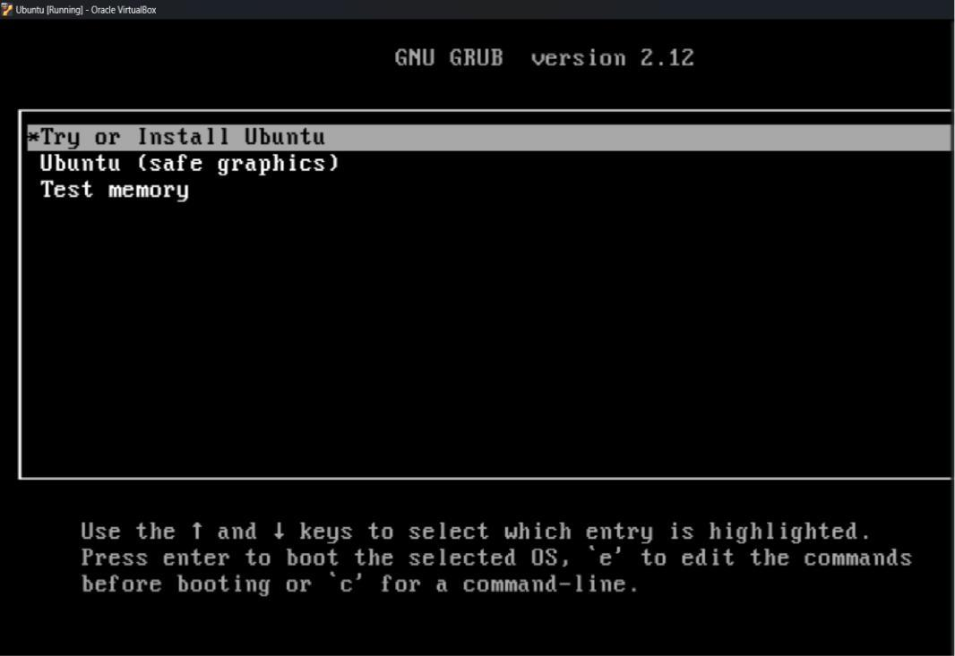When prompted in the black screen (GRUB menu), press **Enter** on: **Try or Install Ubuntu**

**Step 2: Choose "Install Ubuntu"**

* Select language → Click **Install Ubuntu**
* Keyboard layout → Click **Continue**

**Step 3: Installation Options**

* Choose **Normal Installation**
* Select **Erase disk and install Ubuntu**

*(Don’t worry, this erases the* ***virtual*** *hard disk only, not your real system)*

* Click **Install Now** → Confirm if prompted

**Step 4: Set User Info**

* Set your name, computer name, username, and password
* Click **Continue**

**Step 5: Wait for Installation**

* Let it complete (may take 5–10 minutes)

**Step 6: Reboot**

* When it says **Installation complete**, click **Restart Now**
* **Important**: Before reboot, remove the ISO
* Go to **Devices → Optical Drives → Remove Disk from Virtual Drive** o Then press **Enter** to reboot

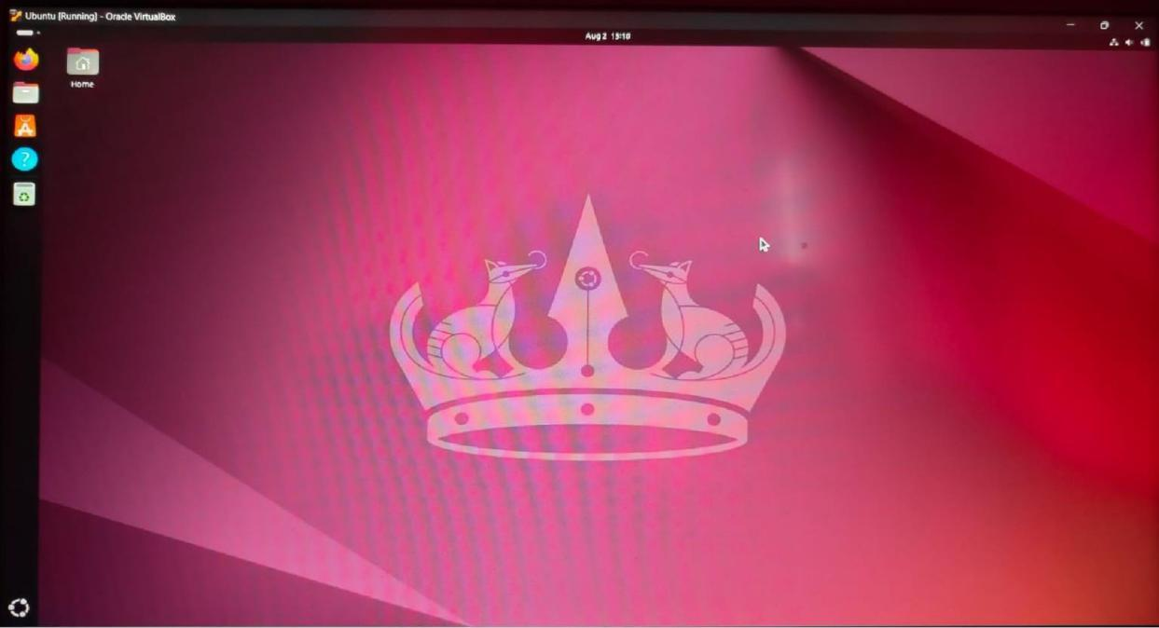

**Done**